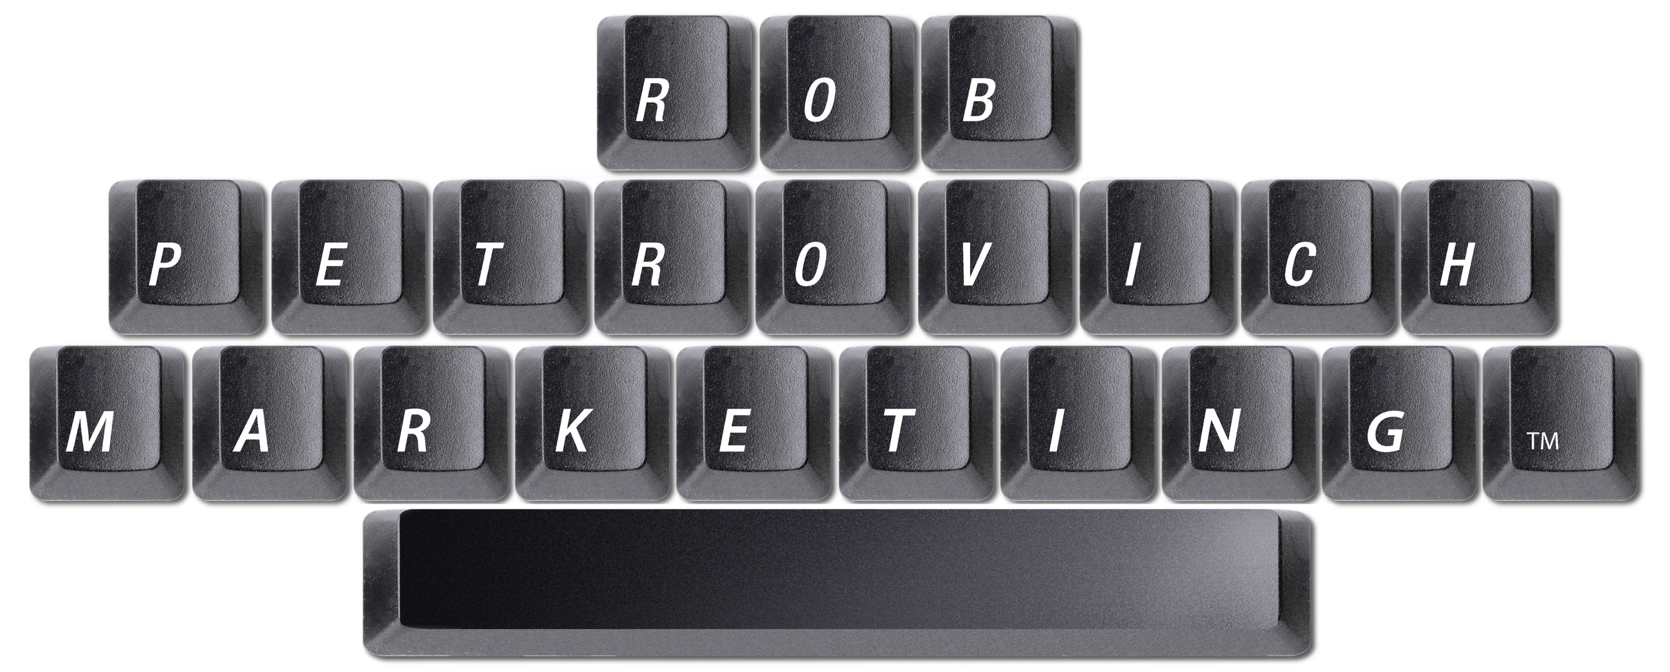

BRAND EMERGENCE 6P PROCESS QUESTIONNAIRE
Unleash Your Brand’s Full Potential

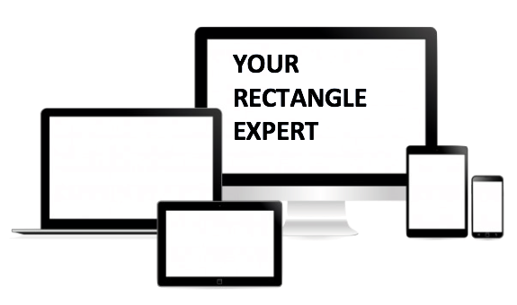

RECTANGLES ARE IMPORTANT.

NO MATTER IF YOUR BRAND COMMUNICATION OCCUPIES THE RECTANGLE SHAPE OF A BILLBOARD…
TV…
COMPUTER…
VIDEO SCREEN…
PRINT AD…
TABLET…
SMARTPHONE…
DIRECT MAIL…
WE BELIEVE IT’S IMPORTANT TO FILL THAT RECTANGLE WITH A COMPELLING BRAND IDENTITY THAT WILL HELP ATTRACT MORE LUCRATIVE CUSTOMERS.

THIS DOCUMENT IS ABOUT HELPING A BRAND GET THE MOST OUT OF ITS RECTANGLE.

ROB PETROVICH MARKETING

P1 – PURPOSE/PICTURE: WHAT ACTION ARE WE TRYING TO ACHIEVE?
What is the marketing objective? Is it share, volume, awareness, etc.?

Where are we planning to go specifically, and what will it look like when we get there?

Paint a vivid picture of the improved reality.

How do we envision the future for the brand?

What is the big opportunity for the brand?

What is the purpose of the advertising?

What do we want our customers to do after seeing the communication?

P2 – PROBLEM: WHAT IS THE COMMUNICATION TRYING TO SOLVE?
What is the consumer problem that advertising will solve?

What problems, issues or concerns have consumers had (if any) with this product in general?

What is most important about the market? Any developments, trends we need to be aware are happening?

What is the most critical issue affecting where we are in the marketplace?

What is the most critical issue affecting where we should be in the marketplace?

What is the “Product” image problem?
(Example: Duracell touts long-lasting power, but is it really a matter of dependability, it’ll work without the worry, etc.?)

What stands in the way of our starting block and the destination?

P3 – PROMISE: WHAT IS BEING DELIVERED TO CREATE VALUE?
What is the answer to the question “Why should I buy this product rather than some other?”

What are the benefits that exist in the product?

What are the attributes that exist in the mindset?

How does our brand differ from the competition in FACT?

How does our brand differ from the competition in PERCEPTION?

Does our product REALLY compete based primarily on a benefit basis, or is/are there other factors involved?

What is the role of the brand?

What is the message our customers want to hear?

What is the difference that the brand intends to make in people’s lives?

It’s not “what is our brand going to do for our customers?” but rather “what are our customers going to be able to do with our brand?” In other words, “How does our brand help people behave, or enable people to behave together that is exciting and inspiring and different from the behaviors that other brands inspire?”

What stance does the brand take? Is it leadership, innovator, etc.?

What is the specific motivation behind the brand? What is our very essence? Our identity? What is true to who we are? What does our brand stand for?

What universal human truth does the brand best reference? What ‘higher calling’ are we providing our customers?

What’s the reward for starting a relationship with our brand?

What’s the reward for continuing to behave this way with our brand?

What will help improve our buyer’s understanding of our brand?

What can we say about our brand/product that can cause a change in belief?

What is the result of using our brand/product? (Gratification? Feel good about themselves? Etc.)

P4 – PERSON/PEOPLE: THIS IS WHO WE ARE TRYING TO REACH.
Who is our conceptual target and what is their core desire?

What is the customer’s relationship with the brand?

How does the target customer currently behave regarding our brand/product?

What do our customer’s think/believe our brand stands for? What is their view? How does it fit in their mind?

How do our customers think and feel about the brand? Why are these relevant?

What do we want prospects to think and/or feel?

Taking the customer’s point of view, is there an opportunity or problem we’re trying to solve? (Example: Instead of saying “Sales are down” is it more accurate to say, “Consumers are choosing cheaper alternatives?”)

How does our product fit into our customers’ lives?

What do we want prospects to do? What action we want them to take?
(Are we asking customers to try our product? Try it again? Reinforce using it? Increase usage? Switch to ours? Raise awareness? Drive traffic?)

Does what our brand stand for – the promise, position, personality – resonate with the target audience? How do we make what we do resonate?

How do we create relevance to our consumers?

How can our brand best align with how people want to behave? Or how can our brand best influence how they and others behave together?

What are points we can aim for to help us think specifically and personally about the target?

How do consumers’ choice in behavior (among and between themselves) affect us? Can we “predict” or “reinforce” a behavior?

Are our customers loyal?

What messages would you create for loyal customers? What would we say if we tried to attract competitor’s customers? How would we speak to someone who is not aware of what we offer?

Do our customers have “customers?”

What do we want our customers to do after seeing the communication?

Is it other brands, habits, attitudes, etc. as to why consumers do/don’t purchase us?

Create a PORTRAIT of the Individual Creative Target? What is their story and how does our brand/product fit into their life? (Go beyond demographics and get into the mindset.)

What is the purchase decision process like?

What is the motivation behind the customer’s needs? (Why are they in the market for our brand/product?)

What considerations does a customer have to think through during their decision process?

How can we create a process to discover new CHOICES for customers, instead of just reiterating benefits?

P5 – PROPOSITION: THIS IS THE INSIGHT WE’VE BEEN SEARCHING FOR.
What is the full brand/product experience? Completely articulate the entire experience.

Does the proposition contain a “Power Idea” or the vehicle that transforms the strategy into a dynamic, creative communication concept?

What is the brand’s strength, not necessarily the point of difference?

What is the consumer benefit? Not what the product is, but what the product will do?

What is the focus of sale, or the principle basis upon which we are asking prospects to purchase the brand?

What is the future we envision for the brand?

What is the selling idea or the conceptual statement that communication will revolve around?

What is the basic benefit, which the brand promises?
- Does that basic benefit constitute the principle basis for purchase?

- What product characteristics make the basic benefit possible?

- Is the basis in which the prospect is being asked to buy our brand clear when compared to other brands?

- Are those benefits “available?” Can competitors say the same thing?

- How does our brand differentiate itself from its competitors? What is the reason people choose our brand and justify paying the price for it?

- What is the ONE reason why the brand will deliver the benefit being promised?

- What is the SINGLE most important idea about the brand we want consumers to feel, notice, believe or take away from the advertising? What information or attributes might help?

P6 – PLAN: THIS IS HOW WE BRING THAT INSIGHT TO LIFE.
When is the customer most likely to notice, be most receptive to, and react favorably to a message?

How does our product fit into our customers’ lives? What are the touch points with the brand?

How does the consumer consume information? (Turn pages, flip through TV, point, swipe, etc.)

How do we get the brand to resonate, or have people appreciate it for what it does and how it makes them feel?

How do we communicate in a way that is simple and clear, so people won’t have to “figure it out?”

What will help us get there? What haven’t we thought of that will help us reach our goal?

What is the most appropriate creative vehicle that will get us there?

What is the most effective, creative, inexpensive, efficient way to achieve the goal?

WHY PEOPLE HIRE ME

I provide world-class marketing ideas to small- and medium-sized owner-driven companies that believe they can’t afford it. I assist organizations in a multitude of industries, but specifically Agriculture, Non-Profit, Outdoor and Attractions & Tourism with advertising, branding, copywriting, creative thinking and strategy. Together, we turn marketing strategies into compelling brand identities. I help companies express complex ideas and strategies in simple creative solutions. I balance both traditional and online marketing tactics and techniques to ensure my clients maintain control of their destiny. I am a thought leader, a public speaker, and your company’s competitive advantage.

YOUR BRAND IS BIGGER THAN YOU THINK.
LET’S DISCUSS WHAT IT CAN BE.

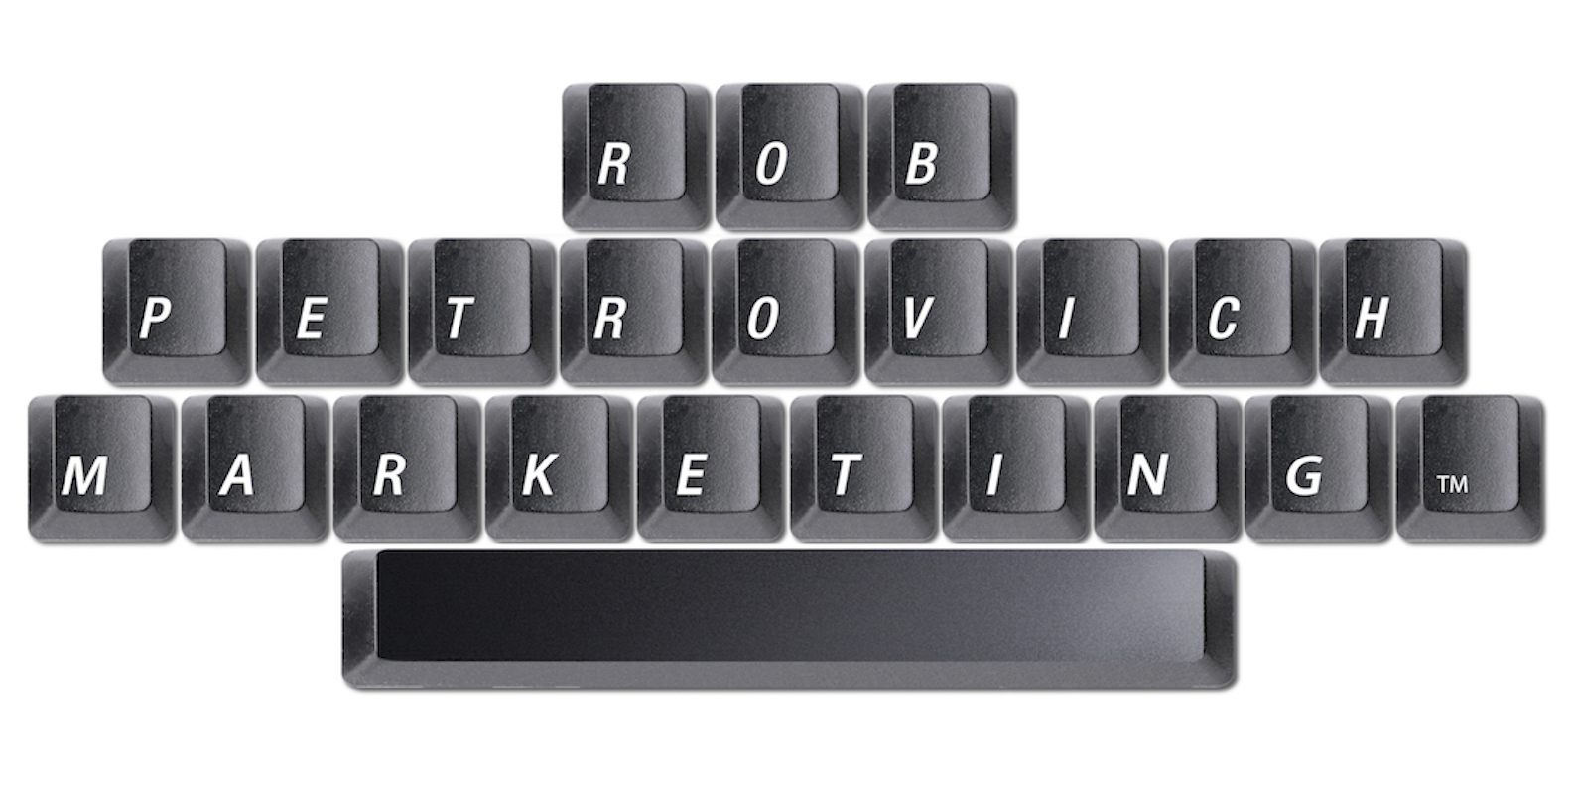

ROB-PETROVICH.COM
ROB@ROBPETROVICHMARKETING.COM
219.743.1070 c
ADVERTISING | BRANDING | COPYWRITING | IMAGINATION | STRATEGY

